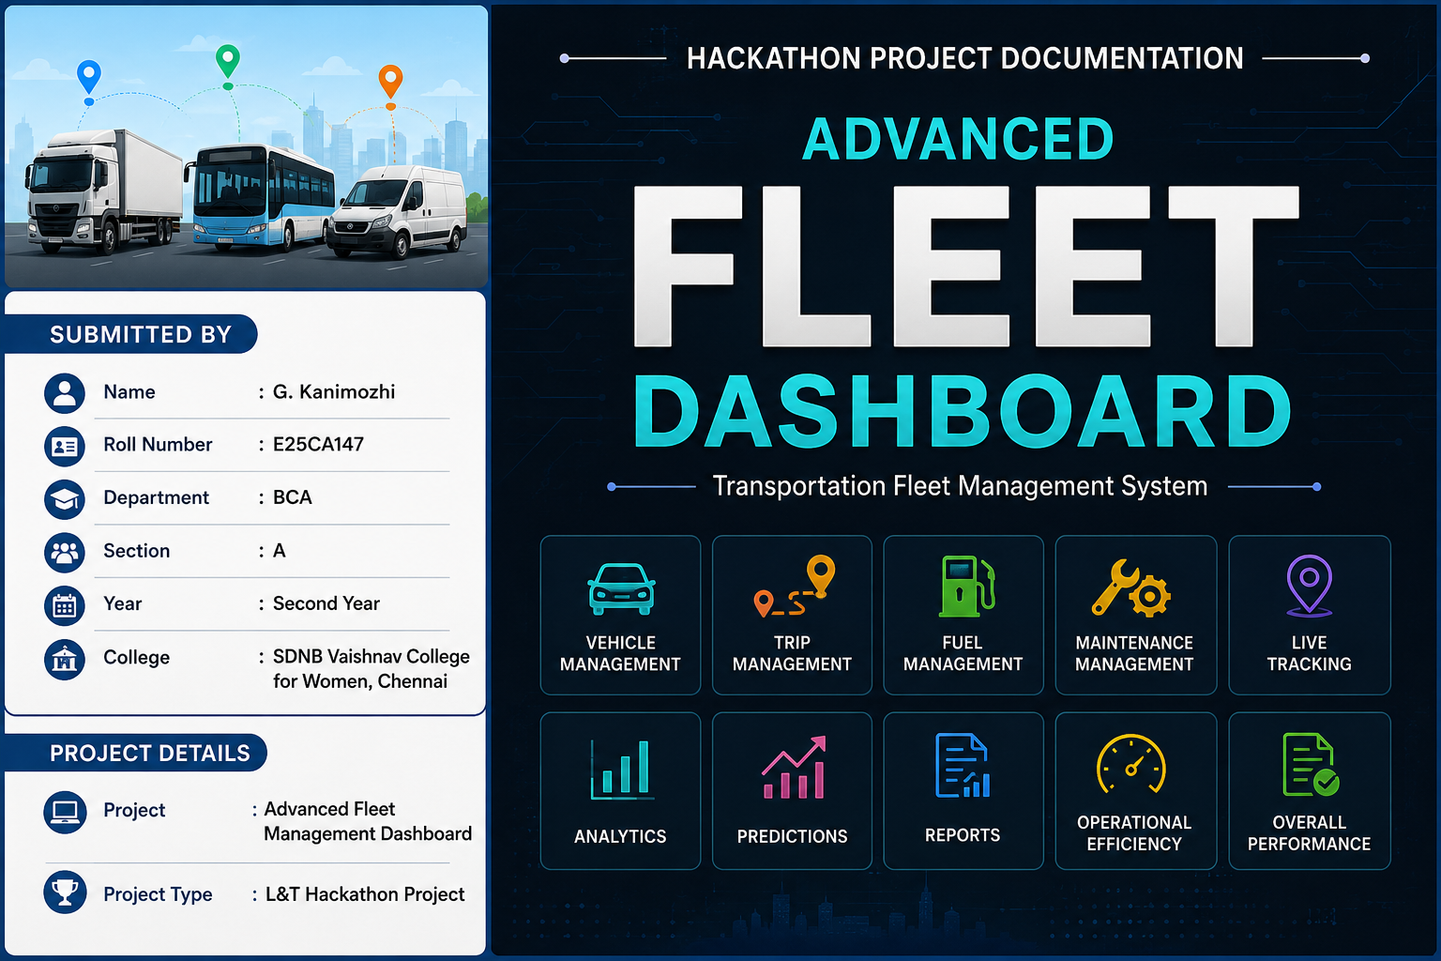

ADVANCED FLEET MANAGEMENT DASHBOARD
Hackathon Project Documentation
Submitted By
G. Kanimozhi
Roll Number: E25CA147
Department: BCA
Section: A
Year: Second Year
College: SDNB Vaishnav College for Women, Chennai
Project: Advanced Fleet Management Dashboard
Project Type: L&T Hackathon Project

1. Introduction
The Advanced Fleet Management Dashboard is a web-based project designed to help fleet managers monitor and manage transportation vehicles from a single dashboard.
In a company, a fleet manager has to handle many activities such as checking vehicle status, monitoring trips, tracking fuel consumption, managing vehicle maintenance, and checking overall vehicle performance.
Our project brings these activities together in one centralized dashboard. This makes fleet information easier to view, understand, and manage.

2. Hackathon Background
This project is developed as a college hackathon project through an L&T-related project initiative at SDNB Vaishnav College for Women.
The hackathon gives students an opportunity to understand real-world company requirements and develop a practical technology-based solution.
Our selected topic focuses on Transportation Fleet Management, especially vehicle utilization, maintenance, fuel consumption, and operational efficiency.

3. Project Topic
Transportation Fleet Management Dashboard
The main areas covered by the project are:
- Vehicle Management
- Vehicle Utilization
- Trip Management
- Fuel Management
- Maintenance Management
- Operational Efficiency
- Live Tracking
- Analytics
- Predictions
- Reports

4. What Does the Project Do?
The dashboard provides a centralized view of fleet operations.
A fleet manager can use the dashboard to:
- View total vehicles
- Check active and idle vehicles
- Identify vehicles under maintenance
- Monitor fuel levels
- Check vehicle speed and location
- Monitor trips and routes
- Track fuel consumption
- Check maintenance schedules
- View fleet performance through charts
- Monitor vehicles on a map
- View reports
- Use prediction features for future maintenance planning

5. How Is It Useful for a Fleet Manager?
A fleet manager has to monitor different types of information every day. Instead of checking each activity separately, this dashboard provides important information in one place.
For example, if a vehicle needs maintenance, the manager can identify it from the Maintenance section. If fuel consumption is high, the manager can check the Fuel Management and Analytics sections. If a vehicle is idle, the manager can identify it and understand vehicle utilization.
The dashboard therefore helps the manager get a quick overview of fleet operations and take suitable actions.

6. Main Modules

6.1 Dashboard
The main dashboard provides an overall view of the fleet.
- Total Vehicles
- Active Vehicles
- Idle Vehicles
- Maintenance Vehicles
- Fleet Health Score
- Vehicle Utilization
- Maintenance Performance
- Fuel Efficiency

6.2 Vehicle Management
This module provides important vehicle details such as:
- Vehicle ID
- Vehicle Type
- Vehicle Status
- Fuel Level
- Speed
- Location

6.3 Trip Management
The Trip Management module helps monitor transportation trips. It contains:
- Trip ID
- Vehicle ID
- Route
- Distance
- Trip Status

6.4 Fuel Management
Fuel Management helps monitor fuel-related information. It can be used to check:
- Fuel Consumption
- Fuel Efficiency
- Total Fuel Used
- Fuel Cost
- Average Fuel Performance

6.5 Maintenance Management
Maintenance is an important part of fleet operations. This module helps managers monitor:
- Service Due
- Overdue Service
- Engine Inspection
- Oil Change
- Brake Inspection
- Tyre Check
- Battery Check
- Maintenance Priority

6.6 Live Tracking
The Live Tracking module displays vehicles on a map. For this project, vehicle locations are simulated for demonstration purposes. The map demonstrates how a real fleet management system could display vehicle locations.

6.7 Analytics
The Analytics section represents fleet performance using charts and visual data. It helps understand:
- Vehicle Utilization
- Fuel Efficiency
- Maintenance Performance
- Operational Efficiency

6.8 Predictions
The Predictions module represents an advanced feature of the system. It can be extended using Machine Learning for:
- Predictive Maintenance
- Fuel Anomaly Detection
- Vehicle Performance Prediction

6.9 Reports
The Reports module provides summarized fleet information. Reports can include:
- Vehicle Reports
- Trip Reports
- Fuel Reports
- Maintenance Reports
- Fleet Performance Reports

7. Advantages of the Project
1. Centralized Monitoring: All important fleet information is available in one dashboard.
2. Easy Vehicle Monitoring: Managers can quickly check vehicle status, fuel, speed, and location.
3. Better Maintenance Planning: Maintenance information helps identify vehicles that require service.
4. Fuel Monitoring: Fuel usage and efficiency can be monitored easily.
5. Trip Visibility: Managers can monitor routes, distances, and trip status.
6. Data Visualization: Charts make fleet information easier to understand.
7. Time Saving: A centralized dashboard reduces the need to check information from different sources.
8. Better Operational Visibility: Managers can get a quick overview of fleet activities.
9. Future Prediction Support: Machine Learning can be added for predictive maintenance and fuel anomaly detection.
10. Scalable System: The system can be extended with more vehicles, users, sensors, and features.

8. Technologies Used

Frontend Technologies
React.js
Used to build the interactive dashboard interface.
JavaScript
Used for application logic and dynamic functionality.
CSS
Used to design and style the dashboard.
Recharts / Chart.js
Used to display fleet information using charts.
React Leaflet / Leaflet
Used to display vehicle locations on a map.

Backend Technologies
Node.js
Used to create the backend environment.
Express.js
Used to create backend APIs and handle requests.

Database
MongoDB / PostgreSQL can be used to store:
- Vehicle data
- Trip data
- Fuel data
- Maintenance data
- User data

Development and Deployment
Git
Used for version control.
GitHub
Used to store and manage the project source code.
GitHub Pages
Used to deploy the frontend demonstration website.

9. Project Data
For demonstration and testing, the project contains 100 Vehicle Records, 100 Trip Records, and 100 Maintenance Records. These are demo/project records created for testing the dashboard. They do not represent the actual number of vehicles owned by L&T.

10. Sample Vehicle Data
Vehicle ID | Type | Status | Fuel | Speed | Location
TN-01 | Truck | Active | 82% | 64 km/h | Chennai
TN-02 | Van | Idle | 54% | 0 km/h | Tambaram
TN-03 | Bus | Maintenance | 35% | 0 km/h | Guindy

11. Sample Trip Data
Trip ID | Vehicle | Route | Distance | Status
TR-101 | TN-01 | Chennai → Bangalore | 346 km | Completed
TR-102 | TN-04 | Chennai → Pondicherry | 160 km | Running
TR-103 | TN-05 | Chennai → Vellore | 140 km | Scheduled

12. Sample Maintenance Data
Vehicle | Issue | Date | Priority
TN-03 | Service Overdue | 15 Aug 2026 | High
TN-07 | Service Due Soon | 18 Aug 2026 | Medium
TN-12 | Maintenance Good | 25 Aug 2026 | Low

13. System Workflow
Login → Dashboard → Select Module → View Data → Analyze Information → Take Suitable Action

Example 1 – Fuel
Fuel Data → Fuel Monitoring → Analytics → Identify High Usage → Manager Action

Example 2 – Maintenance
Maintenance Data → Identify Service Due → Manager Checks Vehicle → Schedule Maintenance

Example 3 – Vehicle
Vehicle Status → Identify Idle/Active Vehicle → Check Details → Manager Action

14. Functional Requirements
- User Login
- Dashboard Navigation
- Vehicle Monitoring
- Trip Monitoring
- Fuel Monitoring
- Maintenance Monitoring
- Live Vehicle Tracking
- Data Analytics
- Predictions
- Reports

15. Non-Functional Requirements
- Good Performance
- Easy Usability
- Reliability
- Security
- Scalability
- Maintainability
- Responsive Interface

16. User Interface
The dashboard contains:
- Login Screen
- Sidebar Navigation
- Dashboard Cards
- Vehicle Tables
- Trip Tables
- Maintenance Tables
- Fuel Information
- Charts
- Map
- Reports
- Prediction Section
The interface is designed to make important fleet information easy to understand.

17. Manager Use Cases
Manager Activity | Dashboard Support
Check vehicles | Vehicle Management
Check idle vehicles | Idle Vehicles
Monitor trips | Trip Management
Check fuel usage | Fuel Management
Check service status | Maintenance
Monitor locations | Live Tracking
Analyze performance | Analytics
Check future maintenance | Predictions
Review information | Reports

18. Future Enhancements
- Real-time GPS Tracking
- IoT Vehicle Sensors
- Real Vehicle Data
- Driver Management
- Advanced User Authentication
- Real-time Notifications
- Machine Learning-based Predictive Maintenance
- Automatic Fuel Anomaly Detection
- Mobile Application
- Automated PDF Reports
- Cloud Database
- Real-time WebSocket Communication

19. Testing
Test Case | Expected Result | Status
Login | Valid user enters dashboard | Passed
Dashboard Navigation | Required page opens | Passed
Vehicle Page | Vehicle details displayed | Passed
Idle Vehicles | Idle vehicles displayed | Passed
Maintenance | Maintenance information displayed | Passed
Fuel Management | Fuel information displayed | Passed
Live Tracking | Vehicles displayed on map | Passed
Analytics | Charts displayed | Passed
Reports | Report information displayed | Passed

20. Conclusion
The Advanced Fleet Management Dashboard provides a centralized solution for monitoring and managing fleet operations.
It combines vehicle management, trip monitoring, fuel management, maintenance, live tracking, analytics, predictions, and reports in one system.
The project demonstrates how modern web technologies can be used to solve real-world fleet management problems.
It also provides a foundation for developing a complete smart fleet management system in the future.

21. References
- React.js Documentation
- Node.js Documentation
- Express.js Documentation
- Leaflet Documentation
- MongoDB Documentation
- GitHub Documentation
- PostgreSQL Documentation

Student Details
Field | Details
Name | G. Kanimozhi
Roll Number | E25CA147
Department | BCA
Section | A
Year | Second Year
College | SDNB Vaishnav College for Women, Chennai
Project | Advanced Fleet Management Dashboard
Project Type | L&T Hackathon Project

